C PROGRAMMING TO FIND SUM OF EVEN NUMBERS THE FIRST N NUMBERS

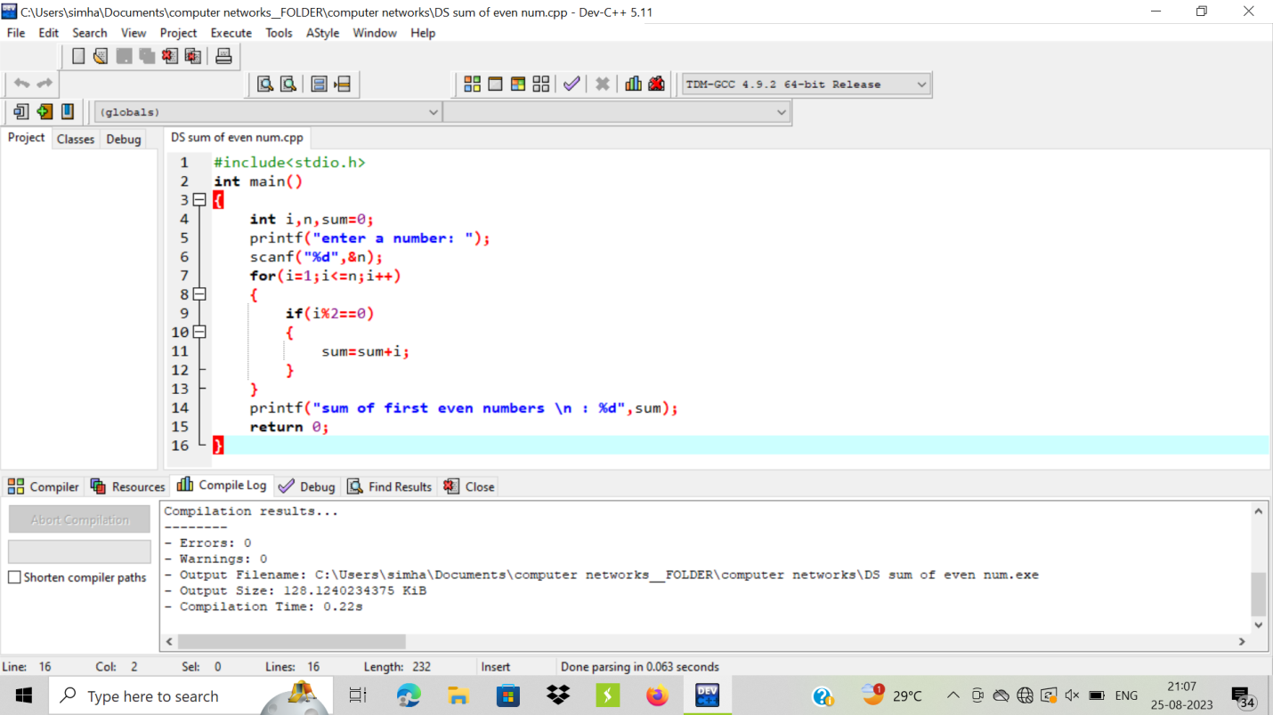

OUTPUT:

